**NATIONAL INSTITUTE OF TECHNOLOGY**

**RAIPUR**



DEPARTMENT OF COMPUTER SCIENCE

AND ENGINEERING

SOFTWARE PROJECT MANAMGMENT

**TERM PROJECT**

CSE- 8th semester

SUBMITTED BY SUBMITTED TO

Name: Duleshwar Kumar Verma Mr. Abhishek Shrivastava

Roll NO.: 18115027

Emotion Detection via Physiological Signals

*Abstract—* ***Some recent research has found that the most influential component in our health is not just physical activities, but also the emotional states we encounter in our everyday lives, which shape our behavior and have a big impact on our physical health. As a result, in recent years, numerous scholars have become increasingly interested in emotion identification. We suggest a two-system in this study. The first use auditory signals to identify emotions, while the second uses IoT sensors like heart rate, skin conductance, and body temperature sensors to read physiological input from the client and apply ml algorithms to distinguish emotional responses.*.**

**1. INTRODUCTION**

Emotions play an important part in understanding human interactions. Researchers are working to develop systems that may simulate the human ability to recognise emotions expressed through facial expressions, tone changes when speaking, and various other means. The aim of the paper is about the detection of the emotions elicited by physiological signals.

Three physiological signals – body temperature, heart rate, and skin resistance. The four basic emotions studied in this study are relaxed, joyful, sad, and furious. The data was collected from 22 healthy male and female people ranging in age from 20 to 22 years. With an accuracy rate of 84 percent, KNN has proven to be the most accurate of all the algorithms applied to the dataset using Weka. We were able to get a 98.75 percent accuracy for each dataset using GRU (Gated recurrent units).

Emotional awareness is beneficial to many institutions and aspects of life. It is advantageous and vital in terms of security and healthcare. It is also required for the rapid and accurate recognition of human emotions at any particular time without the need to question them.

Emotion is an important essential to overall health since it affects our body, mental health, and behavior. Our mental mood has an impact on our immune system, making us much more vulnerable to colds and other minor illnesses. Personal health issues are a cause of stress for much more than 52.5% of Americans, as per the APA. Unmanaged stress can lead to high blood pressure, heart disease, obesity, and diabetes, among other health problems.

As per the ACHA study, a large proportion of students said mental health concerns had a detrimental effect on academic achievement, leading them to drop out or earn bad grades.

Emotion detection offers a wide range of applications, including computer interface, human-biometric security, and more. As a result, it sheds insight on ai technology, or intelligent computers, which use a range of unsupervised and supervised approaches to replicate the human brain.

Smart systems are constantly using emotion detection algorithms to improve their experiences with people. This is crucial because systems may modify their responses and behavioral inclinations in response to user emotions, resulting in a more authentic experience.

**2. RELATED WORK**

This section will discuss extant research that falls into the following categories: video,physiology-based, audio, and emotion identification..

* **Text-based emotion recognition.** The method of finding the emotions of written language utilizing a collection of prepared emotion-labeled statistics and appropriate statistical algorithms is known as emotion detection from text.
* **Emotion detection based on face Facial expressions** and associated variations in facial patterns provide knowledge about a person's emotional situation and aid in conversation regulation. Furthermore, these expressions aid in a better comprehension of the person's overall mood. To identify emotional states, they both use webcams and image analysis technology. Furthermore, in order to identify human emotions, the user must be within the camera's visual range, and even then, the person must be clearly visible.

**Literature reviews from various research papers**

|  |  |  |  |  |  |  |
| --- | --- | --- | --- | --- | --- | --- |
| **Author**  **Name** | **Signals** | **Features** | **Classifiers** | **Emotions** | **Accuracy in %** | **Benefits and Limitations** |
| C.L., Nasoz, Lisetti, | HR  GSR  ST | There are no specific features listed. | Discriminant Function Analysis, Marquardt backpropagation, K-Nearest Neighbors | surprise, Fear, Anger, Sadness, Amusement, Frustration | 91.7 | Angry, fear, and sadness were substantially more closely linked to heart rate than contempt. Happiness was somewhere in the middle. |
| Kim, Andre, J., | EMG  RSP  EDA  ECG | Sub band Spectrum,  Entropy, Statistical, Energy | Linear Discriminant Analysis | Pleasure, Anger, Joy, Sad | 95 | When no overt face variations were present, EMG consistently differentiated between all four scenarios. |
| Schaich, A., Goronzy, S.,Williams, Haag, P., | BVP  RSP  ECG   EMG  EDA | Standard   Deviation   Slope,  Running  mean  Running | Neural network | Valance , Arousal | 89.93 | The error rates obtained were lower  than those found using other  methods. |
| Guang-Yuan, Wan-Hui, Yu-Hui, Q.,  W., | ECG | Fast Fourier | Tabu Search | Sadness, Joy | 86 | Limited size of dataset. Not  suitable for valying  signals. Yield good accuracy. |
| de Santos Sierra,  G.B.D., Avila, C.S.,  Pozo,   J.G., | HR  EDA  Skin conductance | There are no specific features listed. | fuzzy logic | Stress | 93 | Only one emotion can be detected but accuracy is good |
| Pruski, Maaoui, C., | RSP  BVP  EDA  EMG  ST | Statistical Features | Statistical Features | Disgust, Contentment, Amusement, Neutral, Fear, Sad | 99.5 | High accuracy indicates that fear and disgust emotion-specific response patterns may be distinguished from one other and from the neutrality response pattern |
| Kim, J. | SPEECH  RSP  ECG  EMG  EDA  BVP  ST | BRV,Statistical Features, MFCCs, Zero-crossing, | K-Nearest Neighbors | Valance, Arousal | 92 | Because of background noise makes it difficult to predict the real emotions using audio detection. |
| D., Kulic, E.A, Croft, | EMG  HR  EDA | There are no specific features listed. | Hidden Markov model | Valance, Arousal | 81 | When it came to distinguishing between regimes of potential dissatisfaction and regimes of considerably less likely valance, pattern recognition performed much better than random guessing. |

A literature research was conducted in order to analyze the various strategies and methodologies utilized for human emotion identification in order to design the suggested system: Wearable Systems for Physiological Signals-Based Service - In this case, the system gathers information from biomedical signals, predicts emotional state, and takes appropriate action. [1]. Priyank Rathod, Faculty of Computer Engineering, developed a bio-signal related emotion detection device. Six emotions were recognized in this experiment using auditory visuals provided to the subject, as well as physiological signs (HR, SC) and facial gestures. Where bio signals are linked to the emotion anticipated by facial gestures. [2]. Byoung Jun Park's studies on physiological signals and the detection of negative emotions - He looked at negative emotions in this work, such as melancholy and contempt, and used six deep learning algorithms to detect them. The algorithms with the best training and testing performance are shown below. KNN is solely used for testing purposes. [3].

Jerritta S from the Department of Mechatronic Engineering conducted research on Biomedical Parameters Based Human Emotional Expressions: A Review. They evaluated and presented several types of human emotions, as well as how to recognise them using physiological signals, in this study. [4] Emotion Recognition Physiological Biometric Changes in Music Listening, by Jonghwa Kim, IEEE Member - The user's emotions are captured during the audio visuals is displayed in this system, and the feeling is then categorized. Szwoch Wioleta of Gdansk University of Science and technology conducted research on using physiological data for emotion recognition. They looked at temperatures, galvanic skin, heartbeat, blood pulses, respiration, and muscular electrical activity among other physiological signs. This method is complicated since it took into account a variety of physiological cues. [6]. Khadidja GOUIZI's study on biomedical parameters for emotion detection differs depending on which physiological signals are associated with emotions and which parameters are taken from those signals. [7].

Inner Emotions Recognition Through Multi Bio-Signals- Jinho Shin suggested an inner emotion recognition approach based on multi bio-signals in his research. He took five emotions and categorized them using the SVM algorithm. To recognize the emotion, the multiple signals are compared to one another, and the ultimate accuracy is shown. [8]. Emotion classification based on bio-signals - Another study by Eun-Hye Jang of Biohealth IT Converge Technology Research found that emotions can be identified using machine learning techniques based on multi-channel bio-signals. For bio-signal acquisition, he assessed physiological responses coming from emotions such as joy, boredom, sadness, surprise, anger and fear, [9].

**3. METHODOLOGY**

This device recognizes human emotions and shows the person's current emotions. The Arduino Uno board is utilized in the proposed system to read body pulse and temperature from sensors linked to the board. To train the various classes of emotions, the KNN (K closest neighbors) machine learning technique is utilized. In addition, the supplied data must be tested and classified. Here, we're mostly interested in four different emotions: joyful, normal, sadness, and fear.

**3.1 ALGORITHMS**

The GRU model is a well-known LSTM version that combines the forgetting gate and input gate into a single update gate, as well as mixing cell state and hidden state. As a result, the final GRU model is easier to understand and execute than the traditional LSTM model. It will save a lot of time with a tiny degree of difference when training massive data, especially when compared to a regular LSTM model. Both LSTM and GRU may save crucial features and guarantee that they are not lost in long-term transmission by using different Gates. The underlying structure of the GRU model is depicted in Figure, where zt stands for update gate and rt stands for reset gate.

Fig. Internal computing structure of GRU

At time t, the GRU can be calculated with the new state as:



Execute a linear extrapolation between the prior state h t-1 and the current candidate state h t using the revised sequence data. The refresh gate z t decides what more old data should be kept and how much new data should be added. It controls the amount of collection from the previous state that gets transferred into the current one. The greater the value of z t, the more information about previous states comes in. The following is the current state of z t:



Here x represents sample vector at time t, and h t is the candidate state computed in the same way as in a standard RNN network's hidden layer:



where rt signifies a reset gate that regulates the contribution of the prior state to the candidate running state h t. The commitment from the prior state is reduced as the rt value decreases. It will forget the prior state if rt = 0. The reset gate is now as follows:



**3.2 An Overview of** **Dataset**

This dataset comprises temperature, GSR, and heartbeat data collected from people in the 22-23-year-old age bracket. The values are attributed to a certain emotion class. The gender of the person has no bearing on the emotion. The body temperature was recorded in °C., the heart rate in beats/minute (bpm), and the galvanic skin reaction in micro siemens (S).

Fig. Dataset

**3.3 System Architecture**

In this section, we'll go through how to interpret biomedical signals to determine a user's emotional state. In this study, I collect data from consumers using three sensors attached to an Arduino UNO microcontroller. The data of the users is gathered at a frequency of 10 Hz, after which three physiological signals received from non-invasive sensors are processed:

1. The pulse rate per minute is measured using a heart rate sensor. Heart rate fluctuations are induced by a variety of emotions, as well as listening to various music types.

Fig 3.3 Heart rate sensor

1. The electrical conductivity of the skin is measured using the Galvanic Skin Response (Grove GSR sensor). The quantity of sweat released by sweat glands is controlled by GSR. In this scenario, emotion causes our sympathetic nervous system to be stimulated. The stimulation has an effect on our bodies, which become sweaty as a result of sweat gland secretions.

Fig 3.4 GSR sensor

1. The body temperature is measured using a temperature sensor. Body temperature changes as a result of different emotions being activated, as shown.

Fig 3.5 Temperature sensor

Fig System Design Flowchart

The data collecting setup was done in a different cabin. For the next 5 minutes, the same person was asked to express all four feelings. The moods were laid-back, melancholy, furious, and joyful.

To prevent unnecessary noise caused by light, the equipment was contained within a wooden box. With the aid of PLX-DAQ, the data was stored in Excel sheets. Each mood was given its own video and activity.

The data was entered into the Weka programme for categorization using machine-learning algorithms, with at least two separate methods analyzed for maximum accuracy and efficiency. TensorFlow was also suggested for deep learning.

**4. RESULT**

**4.1 Outputs:**

Code Link : <https://github.com/DuleshwarKumarVerma/SPM_Term_Paper_18115027>

**4.2 Confusion Matrix**

1.It is a far superior method of evaluating classifiers.

2. The row reflects what I observe, and the column represents what the classifiers say.

3.The first row represents the actual negative class, whereas the second row represents the actual  positive class.s

4. The top column represents a negative class, while the second represents a positive class.

5. On the main diagonal (top left to bottom right), the best classifier has just TP and TN, i.e. the confusion matrix contains nonzero values only on the main diagonal:

**1. Recall** - It means what percent of actual positive values were correctly classified

 Recall = ____ TP**_____**

(TP +TN)

**2. Precision -** It means what percent of positive predictions were made correct

Precision = ___ TP_____

 (TP+FP)

3. **F1 Score -** A classifier's performance is measured in terms of how well it can classify data (precision and recall) and may be combined into a single statistic called the F1 score.It's precision and recalls harmonic mean.

**Fig. Confusion matrix of GRU**

**4.3 GRU Model Performance**

The x-axis demonstrates the amount of epochs, while the y-axis reflects the model's accuracy. The model's identifying additional as the number of epochs increases. After a certain number of iterations, the model's accuracy remains constant.

Fig 4.3 Accuracy Curve of GRU model

The x-axis shows a number of epochs, while the y-axis shows the model's loss. As the number of epochs rises, the model's accuracy decreases. After some number of epochs loss of the model is constant.

Here, training and testing loss is very low after some epochs, and the gap between training and testing is low, so the learning rate of this model is good.

Fig 4.3 Loss Curve of GRU model

**4.4 Precision for all Emotions:** The precision of Sad and Relaxed is very low because the dataset has very low Sad and Relaxed data, only 724 and 782. The precision of Happy is high because the dataset has very high levels of Happy data, i.e. 5339.

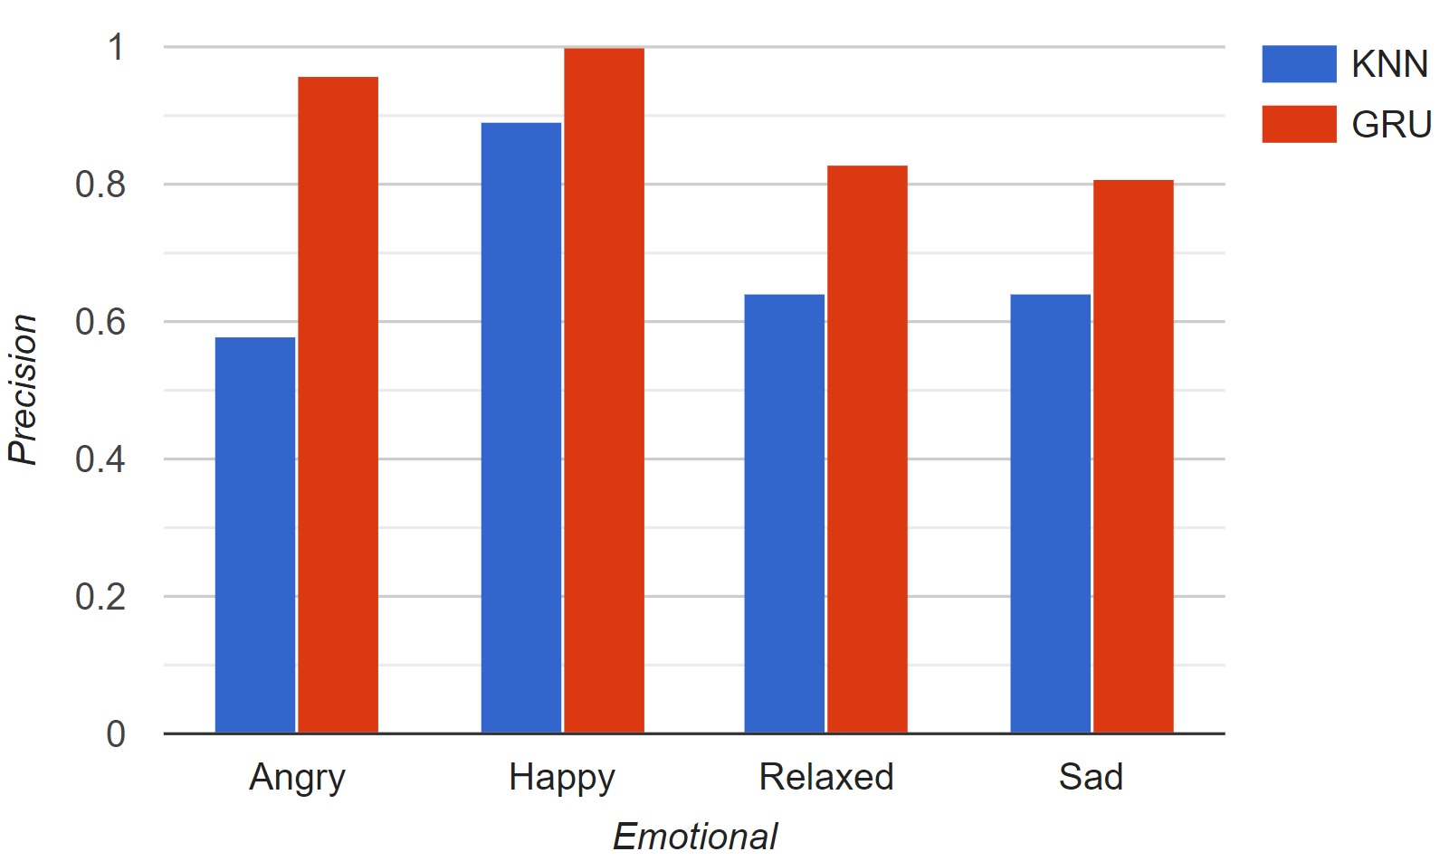

Fig 4.13 Precision of all Emotions

**4.5 Recall for all Emotions:** The Recall of Sad and Relaxed is very low because the dataset has very low Sad and Relaxed data, only 724 and 782. The Recall of Happy is high because the dataset has very high levels of Happy data, i.e. 5339.

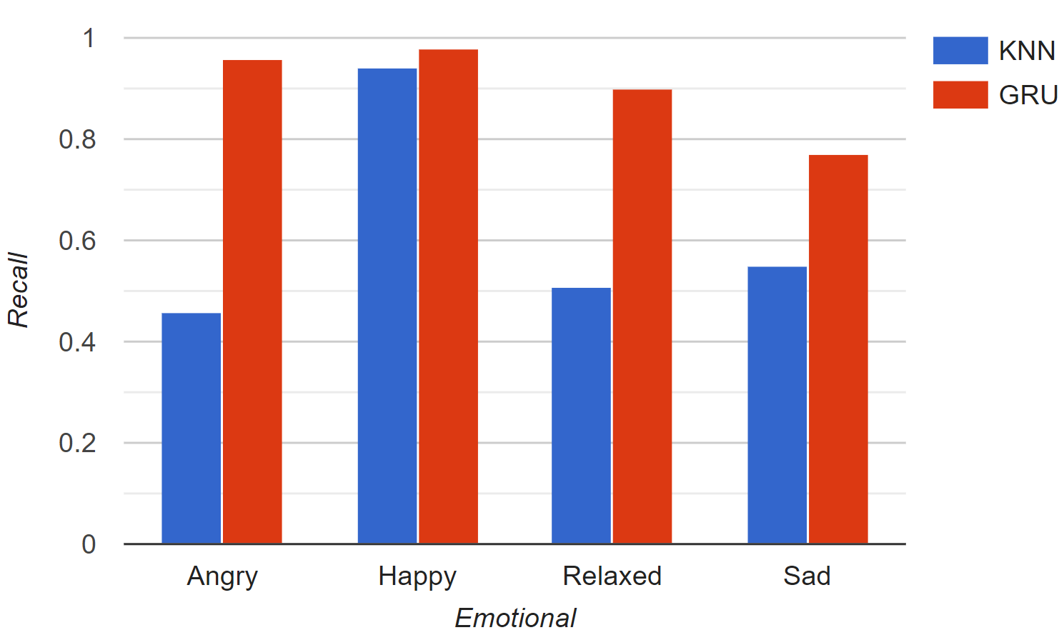

Fig 4.14 Recall of all Emotions

**4.6 F1-Score for all Emotions:** The F1-Score of Sad and Relaxed is very low because the dataset has very low Sad and Relaxed data, only 724 and 782. The F1-Score of Happy is high because the dataset has very high levels of Happy data, i.e. 5339.

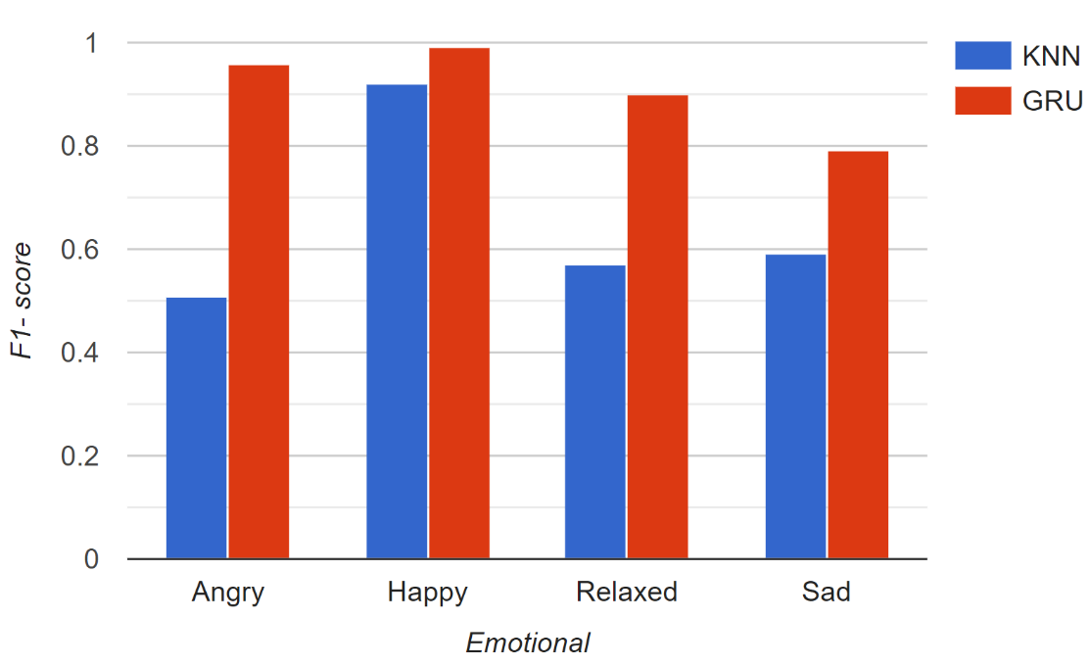

Fig 4.15 F1-Score of all Emotions

**4.7 Model Comparison:** Accuracy, Precision, Recall, F1- Score are evaluated after comparing between two models - KNN and GRU.

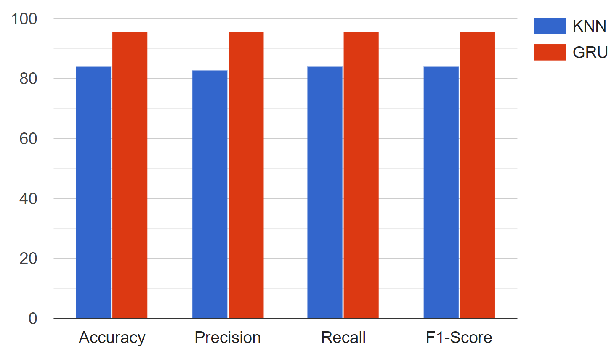

Fig 4.16 KNN VS GRU

**5. CONCLUSION**

I created a method for recognizing human emotions based on physiological information obtained via sensors. Only three physiological signs were taken into account, and emotions were divided into four categories. The emotion is predicted using the GRU model based on the information provided. The accuracy of the GRU model was 96 percent.

The paper's future scope includes expanding the setup by using IoT to detect real emotions. Also, by incorporating a wearable gadget that can immediately display a person's feelings by taking their pulse body temperature, Galvanic Skin Response, and pulse.

For more novel applications and diversions, we will investigate various sorts of user emotional states and propose finding a correlation between these emotions and physical activity which will help in various health sectors and diagnosis of a person.

**6. REFERENCE**

1. J. M. Jinho Shin, Inner emotion Recognition using muli bio signals, in IEEE International Conference on consumer electronics, Jeju, South Korea, 2018.
2. B.-J. P. Eun-Hye Jang, Emotion Classificaton Based on Bio Signals, in International Conference on Information Science, Electronics and Electrical Engineering, Sapporo, Japan, 2019.
3. J. Kim, Emotion Recognition Based on Physiological Changes in Music Listening, IEEE Transactions on Pattern Analysis and Machine Intelligence, vol. 30, no. 12, Dec 2008, pp. 2067-2083, 2018.
4. Nastaran Saffaryazdi, Yenushka Goonesekera, Nafiseh Saffaryazdi, “Emotion Recognition in Conversations Using Brain and Physiological Signals”, 27th International Conference on Intelligent User InterfacesMarch 2022, pp 229–242.
5. Bohdan Myroniv, Cheng-Wei Wu, Yi Ren, and Yu Chee Tseng,“Analysis of Users’ Emotions Through Physiology,” The 11th International Conference on Genetic and Evolutionary Computing, 2017.
6. P. Rathod, Bio-Signal based Emotion Detection Device, in IEEE 13th International Conference on Wearable and Implantable Body Sensor Networks, San Francisco, CA, USA, 2016.
7. Soraia M Alarcao and Manuel J Fonseca. 2017. Emotions recognition using EEG signals: A survey. IEEE Transactions on Affective Computing 10, 3 (2017), 374–393.
8. Mohsin Y. Ahmed,Zeya Chen,Emma Fass,John Stankovic, "Real Time Distant Speech Emotion Recognition in Indoor Environments", Proceedings of the 14th EAI International Conference on Mobile and Ubiquitous Systems: Computing, Networking and ServicesNovember 2017, pp 215–224.
9. Tongshuai Song, Guanming Lu, Jingjie Yan, “Emotion Recognition Based on Physiological Signals Using Convolution Neural Networks”, ICMLC 2020: Proceedings of the 2020 12th International Conference on Machine Learning and ComputingFebruary 2020, pp 161–165.
10. Eibe Frank, Mark A. Hall, and Ian H. Witten (2016). The WEKA Workbench. Online Appendix for "Data Mining: Practical Machine Learning Tools and Techniques", Morgan Kaufmann, Fourth Edition, 2016.

Code Link : <https://github.com/DuleshwarKumarVerma/SPM_Term_Paper_18115027>